**Opik vs. LangFuse**: A Comprehensive Comparison for LLM Application Development

https://www.linkedin.com/in/sumitmishra27598/?originalSubdomain=in

# Introduction

As large language models (LLMs) continue to be integrated into various applications, the need for robust tools to develop, monitor, and optimize these applications is more critical than ever. Two platforms that have gained significant traction in this space are **Opik** and **LangFuse**. Both offer unique features for developing and managing LLM applications, but they cater to different user needs and workflows.

In this blog, we will provide an in-depth comparison of **Opik** and **LangFuse**, exploring their core functionalities, tracing capabilities, prompt management, evaluation tools, and more. This analysis will help developers, teams, and enterprises decide which platform is best suited for their LLM projects

# Overview of Opik

Opik is designed for logging, viewing, and evaluating LLM traces throughout both development and production phases. Its primary focus is on empowering developers to identify and resolve issues efficiently using built-in evaluators. Opik also has SDK support for direct use, you can just setup your account and use it.

### **Key Features of Opik:**

**1. Self-Hosting Options**:

* Local deployment via Docker Compose
* Scalable production deployment with Kubernetes

**2. Comprehensive Tracing**:

* Logging and viewing capabilities
* Annotation of traces
* Support for local and distributed tracing

**3. Integrated Evaluation Tools**:

* Heuristic metrics for performance and relevance
* Hallucination and moderation metrics
* Custom metrics for specific application needs

**4. Testing Frameworks**:

* Integration with Pytest for thorough LLM application testing

**5. Integration**:

Opik simplifies logging, viewing, and evaluating LLM traces with a robust set of integrations. Key features include:

* **OpenAI**: Log all OpenAI LLM calls for easy tracking.
* **LangChain**: Capture logs from LangChain interactions.
* **LlamaIndex**: Monitor LlamaIndex LLM performance.
* **Ollama**: Integrate logging for Ollama LLMs.
* **Predibase**: Fine-tune and serve open-source LLMs while logging their usage.
* **Ragas**: Evaluate Retrieval Augmented Generation (RAG) pipelines effectively.

*\* You can access a comprehensive exploration of Opik from* [*this*](https://github.com/sumitmishra27598/opik/blob/main/OPIK%20Exploration.ipynb) *link.*

# Overview of LangFuse

**LangFuse** is an open-source platform designed to help teams collaboratively develop, debug, and iterate on LLM applications. With an emphasis on tracing, prompt management, and evaluation, LangFuse provides advanced tools for understanding and improving LLM behavior.

#### **Key Features of LangFuse:**

1. **Advanced Tracing Capabilities**:
   * LangFuse captures and ingests traces from all LLM-related processes, providing visibility into complex workflows.
   * It supports multi-modal tracing (text and images), allowing users to trace and debug both simple and complex LLM interactions.
   * Integrations with frameworks like LangChain, OpenAI SDK, and LlamaIndex offer automated tracing setups.
2. **Prompt Management**:
   * LangFuse includes a **Prompt CMS** to store, version, and manage prompts. This decouples prompts from application code and allows teams to update prompts without redeploying the application.
   * The **Prompt Playground** lets developers quickly iterate and test prompts with various LLMs.
3. **Evaluation Metrics**:
   * LangFuse allows developers to attach scores to LLM traces based on model evaluations, user feedback, or manual annotations.
   * Metrics such as latency, cost, and quality are tracked over time, enabling deeper insights into LLM application performance.
4. **Experimentation & Testing**:
   * LangFuse provides A/B testing and dataset management tools, allowing users to test input-output pairs and benchmark performance before deploying changes.
   * It supports tracking versions and releases to understand how updates impact LLM performance.
5. **Integrations**:
   * Supports integrations with popular LLM frameworks and SDKs, including OpenAI, LangChain, LlamaIndex, and more.
   * The platform is designed to be framework-agnostic, offering flexibility for various use cases.

# **Opik vs. LangFuse: High-level Comparison**

### **Tracing Capabilities**

#### **Opik:**

Opik offers flexible tracing options, supporting logging through its REST API or the Opik Python SDK. It integrates seamlessly with LangChain, LlamaIndex, Ragas, Ollama, and Predibase, making it ideal for developers working with multiple LLM frameworks. Traces in Opik capture input, output, and metadata, allowing for basic monitoring and evaluation.

#### **LangFuse:**

LangFuse takes tracing a step further with advanced multi-modal tracing support. This allows users to capture traces involving both text and images, providing a more comprehensive view of LLM interactions. LangFuse’s tracing framework is also built to handle complex workflows involving agents, chains, and tools, making it an excellent choice for applications requiring fine-grained debugging.

**Key Difference**: While both platforms offer robust tracing, **LangFuse** provides more detailed insights, particularly for multi-modal interactions and complex workflows, whereas **Opik** focuses on simplicity and core LLM trace logging.

### **Prompt Management**

#### **Opik:**

Opik does not offer built-in prompt management, leaving developers to manage prompts manually through code. Prompts can be versioned through external systems like Git, but the lack of a dedicated management tool means that updating and organizing prompts may be more cumbersome.

#### **LangFuse:**

LangFuse shines in this area with its dedicated **Prompt Management CMS**, which allows for easy storage, versioning, and retrieval of prompts. Prompts are decoupled from the application code, enabling faster updates without redeployments. Additionally, LangFuse’s **Prompt Playground** allows developers to experiment with prompts and model parameters, facilitating rapid iterations and optimizations.

**Key Difference**: **LangFuse** provides a more efficient and scalable solution for managing prompts, while **Opik** relies on external systems for prompt management.

### **Evaluation and Metrics**

#### **Opik:**

Opik simplifies metric definition by allowing developers to set up heuristic and LLM-based judge metrics easily. It also supports custom metrics for specialized use cases, making it an excellent tool for quickly evaluating LLM performance. Opik summarizes results in the CLI or notebook, making it accessible for on-the-fly evaluations.

#### **LangFuse:**

LangFuse provides a more comprehensive evaluation framework, supporting both model-based and manual evaluations. Developers can collect user feedback and annotate traces to improve LLM performance continuously. LangFuse also supports automatic scoring of LLM outputs and offers dashboards to track performance metrics over time.

**Key Difference**: **LangFuse** offers a more detailed evaluation framework with built-in tools for model-based assessments and continuous monitoring, while **Opik** focuses on simplicity and ease of use with basic, customizable metrics.

### **Self-Hosting and Scalability**

#### **Opik:**

Opik provides two self-hosting options: a local installation for testing and quick setups, and a Kubernetes-based deployment for scalable production environments. While these options are straightforward, they may not include advanced monitoring and user management features in self-hosted mode.

#### **LangFuse:**

LangFuse can be self-hosted or used as a managed cloud service. Its architecture is designed for enterprise-level scalability, with multiple components (frontend, backend, API) that provide more robust features, including user management, advanced monitoring, and data security measures like SOC2 and ISO27001 compliance.

**Key Difference**: **LangFuse** offers a more comprehensive self-hosting solution, particularly for enterprises that need advanced scalability, security, and monitoring capabilities. **Opik** is better suited for small teams or developers looking for a simpler, more lightweight self-hosting option.

### **Usability**

#### **Opik:**

Opik is ideal for developers who prefer a lightweight, user-friendly interface. Its setup process is straightforward, making it a great tool for quick implementations and individual projects. The simplicity of Opik makes it accessible for developers who may not need extensive customization or enterprise-grade features.

#### **LangFuse:**

LangFuse requires more initial configuration but offers greater depth in terms of tracing, evaluation, and prompt management. Its interface is designed for teams that need detailed insights into LLM performance and the ability to iterate on complex workflows. LangFuse’s usability is better suited for larger teams and production-grade applications.

**Key Difference**: **Opik** provides ease of use for smaller projects or teams, while **LangFuse** is designed for teams that require more advanced tools and scalability.

### **Dataset Management: Opik vs. LangFuse**

#### **Opik:**

* **Basic Dataset Display**: Opik offers a straightforward view of dataset inputs and outputs, making it easier to visualize how models are processing the data. However, its dataset management lacks advanced features for deep analysis.
* **Limited Experimentation Support**: Opik does not offer advanced dataset experimentation tools. It is focused on providing basic information about datasets rather than detailed insights or comparisons across different versions of models or prompts.
* **No Dataset Versioning**: Opik does not provide built-in support for dataset versioning or benchmarking. Users must manage datasets manually outside of the platform if version control is needed.
* **No Advanced Visualizations**: Opik does not offer graphical tools or dashboards to display trends or insights from datasets.

#### **LangFuse:**

* **Advanced Dataset Management**: LangFuse excels in managing datasets by offering detailed support for versioning and experimentation. It allows users to create, modify, and manage datasets directly within the platform, enabling a streamlined workflow.
* **Experimentation and Testing**: LangFuse allows users to perform A/B testing and benchmark dataset performance with input-output pair comparisons. This is particularly useful for tracking how different prompts or models perform across various datasets.
* **Dataset Versioning**: LangFuse supports dataset versioning, making it easy to track changes and improvements across multiple versions of a dataset. This is essential for continuous experimentation and improving model performance over time.
* **Rich Visualizations**: LangFuse offers advanced visualizations that display key trends and insights from datasets. This includes charts and metrics that help users better understand how LLMs are performing with specific datasets.
* **Dataset-wise Experimentation**: LangFuse supports conducting experiments on specific datasets, allowing users to test multiple input-output pairs and explore different dataset formats (e.g., key-value pairs, LLM chat data) to gain insights into model performance.

**Key Differences: Opik** offers a basic dataset management experience, suitable for smaller projects or developers who do not require extensive experimentation or detailed analysis. **LangFuse** provides a more comprehensive dataset management system, ideal for teams or enterprises needing to version, experiment, and analyze datasets in detail. It offers the tools necessary for deep insights and continuous optimization of LLM applications.

The table below highlights the functionality supported in Opik vs. LangSmith:

| **Feature/Functionality** | **Opik** | **LangFuse** |
| --- | --- | --- |
| Open-Source | ✅ | ✅ |
| Self-hosting Support | ✅ | ✅ |
| Dataset | ✅ | ✅ |
| Tracing | ✅ | ✅ |
| Evaluation | ✅ | ✅ |
| Pytest Integration | ✅ | ❌ |
| OpenAI Support | ✅ | ✅ |
| LangChain Support | ✅ | ✅ |
| LlamaIndex Support | ✅ | ✅ |
| Ollama Support | ✅ | ❌ |
| Predibase Support | ✅ | ❌ |
| Ragas Support | ✅ | ❌ |
| LangGraph Cloud Support | ❌ | ❌ |
| Own Prompt Management | ❌ | ✅ |
| Capture Human Feedback | ❌ | ✅ |
| Advanced Monitoring & Automations | ❌ | ✅ |
| Prompt Management CMS | ❌ | ✅ |
| Multi-modal Tracing (Text and Image) | ❌ | ✅ |
| Model-based Automated Evaluations | ❌ | ✅ |
| Advanced Experimentation (A/B Testing, Dataset Benchmarking) | ❌ | ✅ |
| Detailed Analytics Dashboards (Cost, Latency, Quality Metrics) | ❌ | ✅ |

# Comparative Experiment

In this experiment, I explored the performance and integration capabilities of both **Langfuse** and **Opik** in a tracing scenario within an LLM-based project. The primary objective was to evaluate how these tools could help trace and monitor the execution flow in a complex retrieval-augmented generation (RAG) system aimed at analyzing company directors’ backgrounds for independence. We implemented a RAG system for answering questions on 10k statements. This RAG system uses prompting techniques, ReAct (Reason+act) and Reflection.

## LLM Workflow Summary:

**LLM Model**:

* The system uses GPT-3.5-turbo as the core language model to generate responses and analyze queries related to the independence of company directors.

**Preprocessing**:

* Documents like SEC filings are loaded and split into smaller chunks of text (500 characters) for better embedding and retrieval later. This ensures context is maintained across chunks.

**Embedding and Vector Store (FAISS)**:

* HuggingFace’s BGE model creates embeddings of the text chunks.
* FAISS vector store is used to store these embeddings, making it possible to retrieve relevant document sections efficiently during querying.

**RAG Chain for Document Retrieval**:

* Retrieval-Augmented Generation (RAG) framework pulls relevant information from the stored document chunks based on the user’s queries.
* This ensures that responses are grounded in actual data from filings and other sources.

**Reranking with Cohere**:

* A reranking mechanism improves search results by ranking the top N relevant chunks using Cohere’s model, ensuring the most pertinent information is prioritized.

**Query Decomposition**:

* Complex queries are broken down into smaller, more manageable sub-queries using GPT-3.5-turbo. This ensures that multiple aspects of a question are addressed comprehensively.

**Director Analysis Tools**:

* Names of directors are extracted, LinkedIn profiles are searched, and detailed background information (education, career history) is gathered through ProxyCurl integration.

**REACT Agent with Reflexion**:

* The REACT agent follows a cycle of Thought → Action → Observation → Reflection.
* It iteratively collects and analyzes data (e.g., LinkedIn profiles, document sections) to determine the independence of company directors.

**Final Execution**:

* Once all necessary information is gathered, the system processes complex queries related to director independence by combining the RAG retrieval with the REACT agent’s reflection-based analysis for thorough, data-backed conclusions.

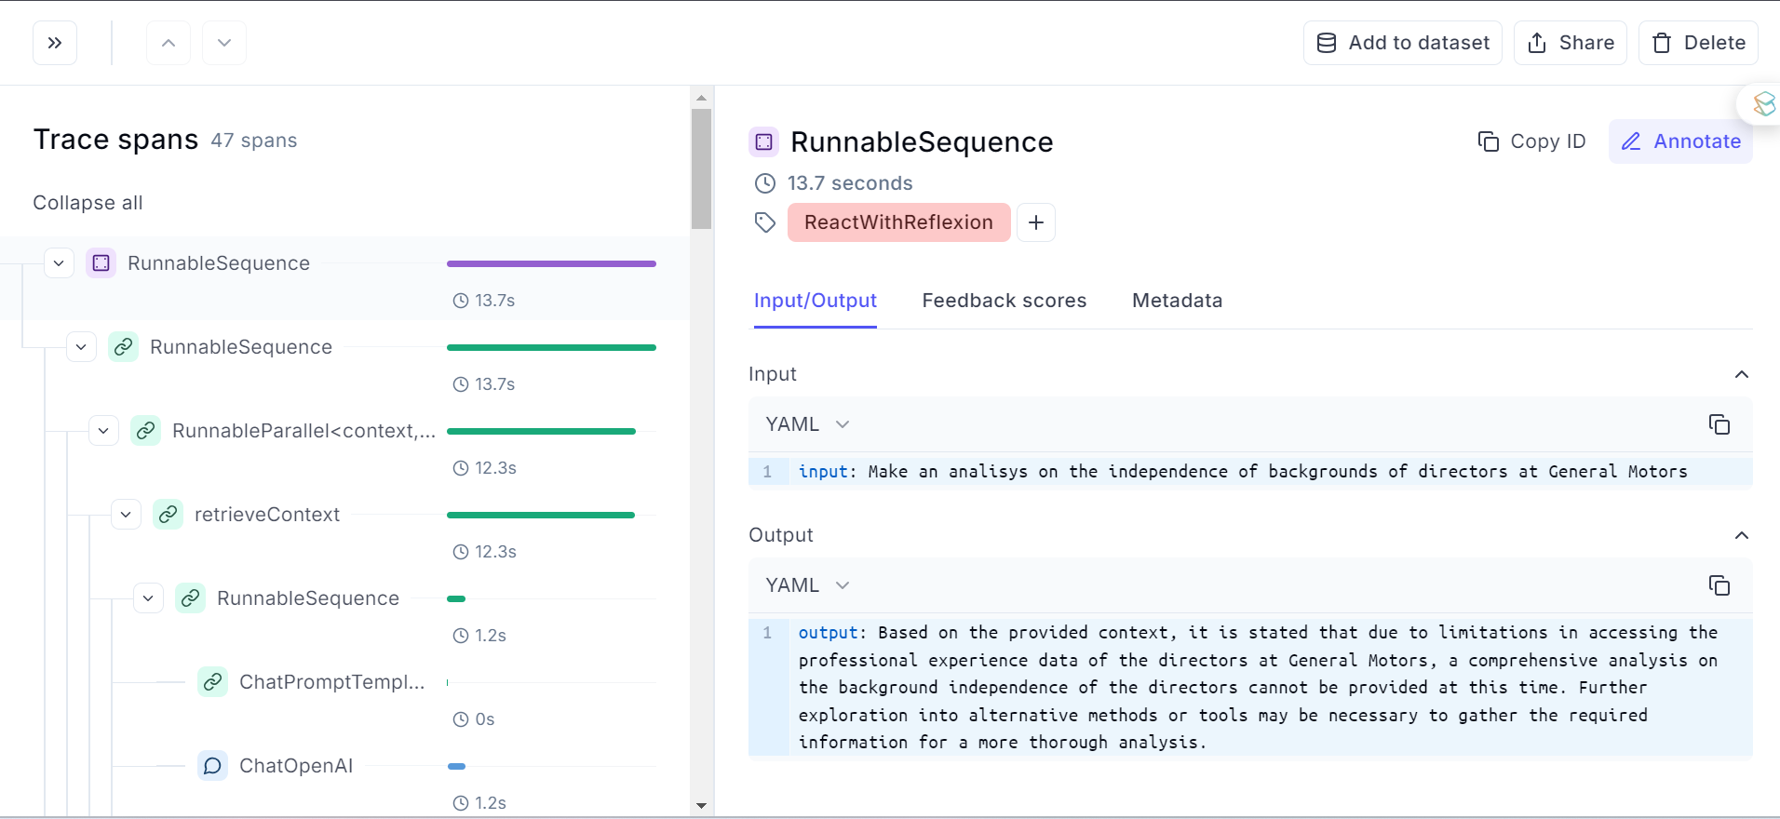

Opik Tracing

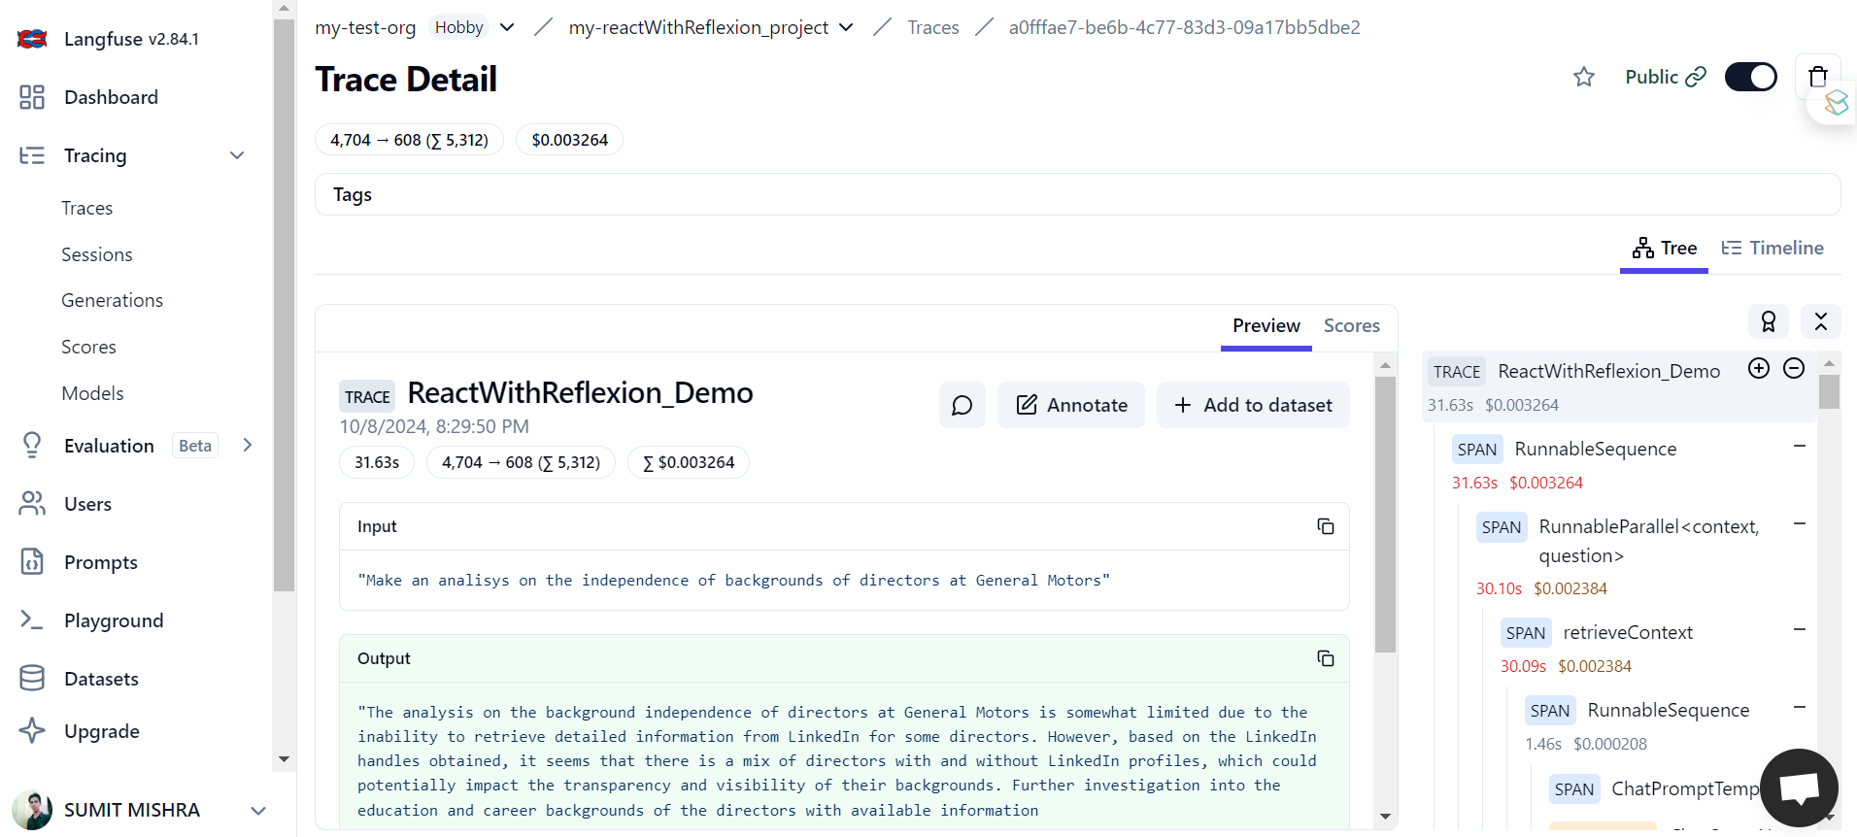

LangFuse Tracing

Both images showcase the tracing details of our workflow, focusing on different levels of trace detail. Here's a comparison based on the UI and functionality shown in both images:

### **1. Trace Visualization and Structure**

#### **LangFuse**

* **Hierarchical Trace Structure**: LangFuse’s UI presents a **tree-like structure** for spans. The trace is broken down into individual spans that correspond to different steps or actions taken during the workflow.
  + For example, the root trace (ReactWithReflexion_Demo) shows high-level details such as duration (31.63s), token usage (4,704 → 608), and cost ($0.003264).
  + Below it, the sub-spans show the execution flow, such as RunnableSequence, RunnableParallel<Context, Question>, and retrieveContext. This hierarchical view makes it easier to understand how different tasks are executed and in what sequence.
  + You can see **parallel** and **sequential spans**, which are helpful for understanding complex workflows like your REACTwithReflexion system, where multiple subtasks may run simultaneously (such as querying data and performing reflection).
* **Span Details and Token/Cost Breakdown**:
  + The cost and execution time of each sub-span are highlighted in the right panel, providing a granular view of the process. For example, the RunnableParallel step consumed 4,704 tokens and incurred a cost of $0.002384.
  + This level of breakdown allows you to pinpoint which specific steps in the workflow are consuming the most resources, offering a clear way to optimize performance.
* **Preview and Scores Tab**:
  + LangFuse provides the ability to **annotate** each span, making it easy to add notes or observations directly on the trace. You can also **add spans to a dataset**, enabling further experimentation or performance tracking.

#### **Opik**

* **More Simplistic Tree Structure**: Opik also provides a tree-like breakdown of spans in the trace, but the visualization is simpler. The root span (RunnableSequence) shows the overall duration (13.7 seconds), and sub-spans are nested beneath it.
  + Compared to LangFuse, Opik seems to emphasize **execution time** more prominently, with the duration of each step being highlighted directly in the tree view.
  + However, the view doesn’t show **cost or token breakdown** directly in the tree structure like LangFuse does. You have to click into each span to get additional details on cost and token usage.
* **Less Hierarchical Detail**:
  + While the spans are nested, Opik’s interface does not seem to provide the same depth of hierarchical information as LangFuse. The interface shows a **more flattened structure**, which is useful for simpler workflows but may not capture the full complexity of multi-level workflows like your REACT-based system.
  + LangFuse offers clearer distinctions between sequential and parallel steps, while Opik appears more focused on **sequential operations**.

### **2. Input/Output Display**

#### **LangFuse:**

* **Detailed Input/Output Panel**:
  + LangFuse allows users to view the input and output of each step directly within the **Preview panel**. For instance, the input for the ReactWithReflexion_Demo is a question about the independence of directors’ backgrounds, and the output is a detailed analysis.
  + The interface also provides a clear breakdown of the exact input/output at each stage, offering a more thorough way to debug or evaluate the system's performance at different steps.
* **Integrated Cost and Token Usage Information**:
  + LangFuse's integration of cost and token usage into the **Preview** panel adds context to the resource consumption of specific operations. This feature is beneficial for tracking how much each LLM query costs in real-time, especially when optimizing cost and performance.

#### **Opik:**

* **Input/Output in YAML Format**:
  + Opik provides an **Input/Output tab** that displays the input and output for each step, but the details are shown in YAML format. This format may be more developer-friendly but can be less readable at a glance compared to LangFuse’s formatted text view.
  + For example, the input for the RunnableSequence is also the question regarding the background independence of directors, and the output includes a summary analysis. However, Opik’s interface requires more navigation to drill down into the specifics of each span's input/output.
* **Lacks Cost/Token Breakdown in Output View**:
  + Unlike LangFuse, Opik does not integrate cost and token information directly in the input/output panel, making it more challenging to connect resource consumption to specific stages of the workflow.

### **3. Annotations and Dataset Integration**

#### **LangFuse:**

* **Annotations and Dataset Integration**:
  + LangFuse allows users to annotate each span, which can be highly useful in complex workflows where you need to document observations or reasons behind key decisions.
  + Additionally, the option to **add specific traces or spans to datasets** is helpful for further analysis, especially in cases where you're running multiple experiments and want to compare performance across different runs.

#### **Opik:**

* **Annotate but No Dataset Integration**:
  + Opik has an option to **annotate** spans, but it lacks the feature to integrate specific traces into datasets directly from the UI, limiting its flexibility for managing long-term experiments or datasets.

### **4. Performance Metrics and Feedback Scores**

#### **LangFuse:**

* **Rich Performance Metrics**:
  + LangFuse provides more in-depth performance metrics such as latency, token usage, and cost breakdown, all of which can be seen at both the span and trace levels. This allows for granular performance tuning and a better understanding of how each step affects overall system performance.
  + **Feedback Scores**: LangFuse also allows for **user feedback scores** and performance evaluations, helping to monitor the system’s performance and user satisfaction over time.

#### **Opik:**

* **Simplified Metrics**:
  + Opik’s interface focuses more on execution time for each span but doesn’t provide as much detailed performance analysis (e.g., token usage and cost per step) as LangFuse.
  + There is no clear interface for capturing **feedback scores** within the trace view, which limits the ability to monitor how each trace contributes to the perceived quality of results.

### **5. Hierarchical Trace Detail:**

#### **LangFuse:**

* + **LangFuse** provides deeper, more complex hierarchical trace structures, which are better suited for workflows like the REACT-based reflection system where multiple actions, thoughts, and reflections happen in parallel or sequentially.

#### **Opik:**

* + **Opik** presents a simpler, more linear breakdown of spans, focusing mainly on execution time without the detailed parallel vs. sequential span distinction.

### **6. Cost/Token Breakdown**:

#### **LangFuse:**

* + **LangFuse** integrates cost and token usage data into every span, allowing for better resource tracking and optimization.

#### **Opik:**

* + **Opik** focuses primarily on execution time without integrating cost and token usage information as visibly or in as much detail.

### **7. Input/Output and Metadata**:

#### **LangFuse:**

* + **LangFuse** offers a more user-friendly presentation of input/output, integrating it with cost metrics and making it easier to navigate.

#### **Opik:**

* + **Opik** shows the input/output in a YAML format, which may appeal to developers but is less visually intuitive.

### **8. Annotations and Experiment Management**:

#### **LangFuse:**

* + **LangFuse** excels with the ability to annotate spans and integrate specific traces or spans into datasets, making it ideal for long-term experiments and detailed debugging.

#### **Opik:**

* + **Opik** allows annotations but lacks advanced dataset integration or long-term experimental comparison tools.

# Conclusion

Both **Opik** and **LangFuse** provide valuable tools for large language model (LLM) application development, but they cater to different user needs and project scales.

**Opik** is ideal for developers who prioritize **open-source** flexibility and a user-friendly setup. Its straightforward metric definition, extensive integrations, and simplicity make it well-suited for quick implementations, personal projects, and small teams. However, Opik’s limited tracing capabilities, lack of built-in prompt management, and absence of advanced dataset management or automated evaluation features may pose challenges in enterprise settings. These gaps can hinder comprehensive performance analysis and monitoring, particularly in projects requiring detailed compliance, robust feedback systems, and privacy regulations.

In contrast, Opik is more simplified and focuses on basic tracing and execution time, making it suitable for developers who need a lightweight solution for tracing LLM operations but may not require the level of depth provided by LangFuse.

On the other hand, **LangFuse** excels in environments where stability, scalability, and comprehensive monitoring are critical. Its **advanced tracing capabilities**, prompt management CMS, and rich dataset and evaluation features facilitate deeper insights and collaboration. LangFuse’s robust architecture, combined with built-in automation tools and multi-modal trace support, enables teams to proactively manage issues and improve application performance. These features make LangFuse a strong choice for enterprises building production-grade LLM applications, where advanced monitoring, data security, and continuous evaluation are essential.

LangFuse is clearly more suited for complex workflows, detailed performance tracking, and enterprise-level applications where you need to track every step, cost, token usage, and user feedback in a detailed and organized manner.

For **individual developers** and smaller teams, Opik offers a flexible and accessible platform, especially for experimentation and rapid development. Its open-source nature allows for customization and adapts to various project needs. However, for **enterprises** or larger teams aiming to deploy scalable, production-ready applications, LangFuse provides the advanced capabilities needed to ensure stability, monitoring, and compliance at scale.

In conclusion, the choice between Opik and LangFuse depends on the specific needs of the user. Opik is well-suited for individuals and small teams focused on flexible, open-source projects, while LangFuse is better for organizations that require enterprise-grade solutions with sophisticated tracing, monitoring, and evaluation features. Aligning your tool choice with your project requirements and long-term goals will ensure success in your LLM development journey.

Both **Opik** and **LangFuse** provide valuable tools for large language model (LLM) application development, but they cater to different user needs and project scales.

**Opik** is ideal for developers who prioritize open-source flexibility and a user-friendly setup. Its straightforward metric definition, extensive integrations, and simplicity make it well-suited for quick implementations, personal projects, and small teams. However, Opik’s limited tracing capabilities, lack of built-in prompt management, and absence of advanced dataset management or automated evaluation features may pose challenges in enterprise settings. These gaps can hinder comprehensive performance analysis and monitoring, particularly in projects requiring detailed compliance, robust feedback systems, and privacy regulations.

On the other hand, **LangFuse** excels in environments where stability, scalability, and comprehensive monitoring are critical. Its advanced tracing capabilities, prompt management CMS, and rich dataset and evaluation features facilitate deeper insights and collaboration. LangFuse’s robust architecture, combined with built-in automation tools and multi-modal trace support, enables teams to proactively manage issues and improve application performance. These features make LangFuse a strong choice for enterprises building production-grade LLM applications, where advanced monitoring, data security, and continuous evaluation are essential.

For individual developers and smaller teams, **Opik** offers a flexible and accessible platform, especially for experimentation and rapid development. Its open-source nature allows for customization and adapts to various project needs. However, for enterprises or larger teams aiming to deploy scalable, production-ready applications, **LangFuse** provides the advanced capabilities needed to ensure stability, monitoring, and compliance at scale.

In conclusion, the choice between Opik and LangFuse depends on the specific needs of the user. **Opik** is well-suited for individuals and small teams focused on flexible, open-source projects, while **LangFuse** is better for organizations that require enterprise-grade solutions with sophisticated tracing, monitoring, and evaluation features. Aligning your tool choice with your project requirements and long-term goals will ensure success in your LLM development journey.